OptiFlow (AI-OrchestrateX) Proposal

# Executive Summary

OptiFlow (AI-OrchestrateX) is a domain-specific, AI-native orchestration platform designed to automate and manage microservices, AI models, and data workflows. Its architecture combines the strengths of Kubernetes-like control with the flexibility needed for real-time and batch processing across diverse industries.

# Problem Statement

Traditional orchestrators fail to bridge the gap between domain-specific automation, AI-driven services, and real-time model deployments. Enterprises need a solution that supports scalable orchestration across cloud, on-prem, and edge environments.

# OptiFlow Architecture & Components

OptiFlow comprises an API Server, Scheduler, Controller Manager, MPODs (Modular/Micro Pods), a Networking Layer, and a Distributed Storage Backend. It's built for async processing, health monitoring, and workload orchestration.

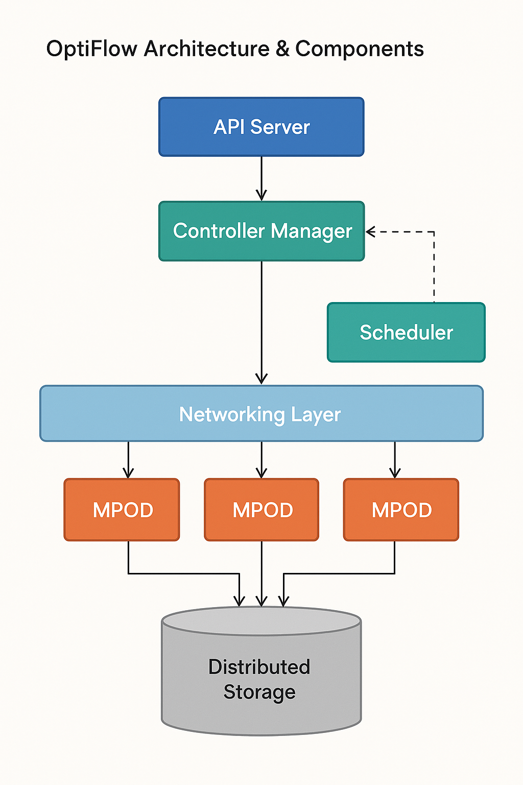

Fig-1

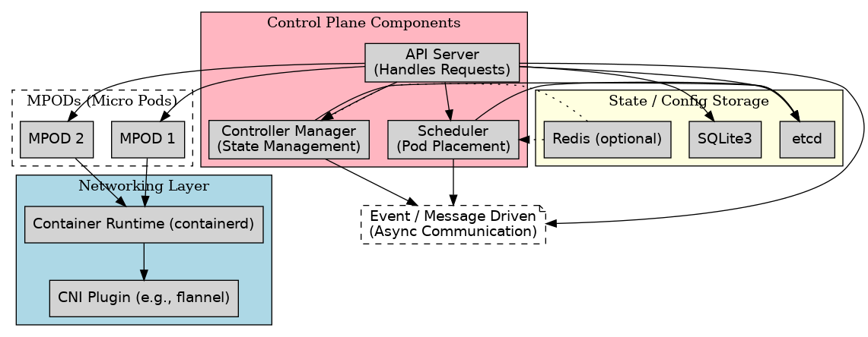

# Fig-2

# Key Differentiators (AI-aware scheduling, MPODs, etc.)

OptiFlow supports AI-aware scheduling, real-time MPOD-based orchestration, integrated API Gateway + Load Balancer, and is natively GPU-aware for optimized inference workloads.

# Business Value Across Domains (Healthcare, Manufacturing, etc.)

OptiFlow empowers enterprises in healthcare (e.g., organ segmentation), manufacturing (sensor-driven workflows), space (satellite data processing), and more through scalable, real-time orchestration.

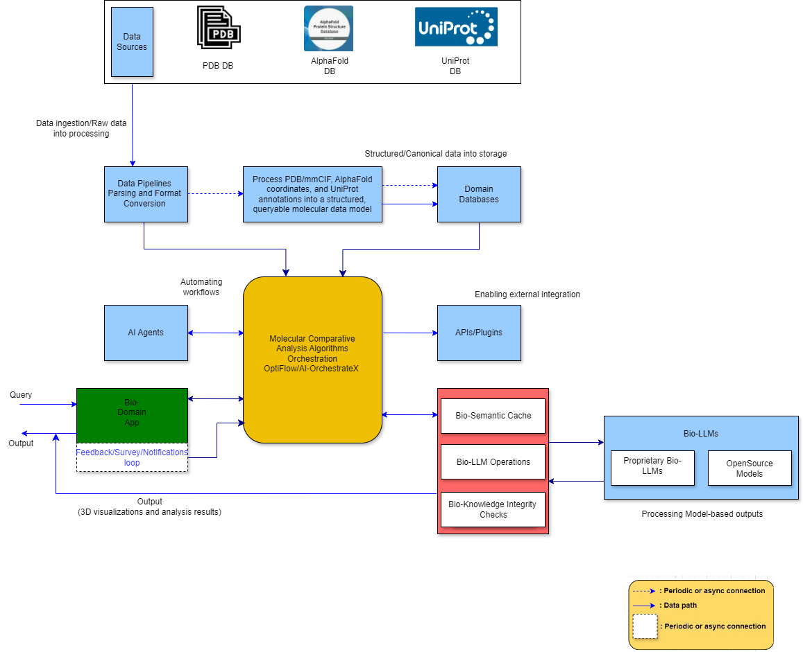

# Fig-3

# Deployment and Scalability Roadmap

OptiFlow supports deployments on WSL, cloud platforms, and bare-metal servers. It scales horizontally using MPODs and supports load distribution across environments.

# Core & Storage Architecture

The core engine uses async controllers and thread workers. The storage layer is built using SQLite/Postgres, enabling persistence, job tracking, and state management across MPODs.

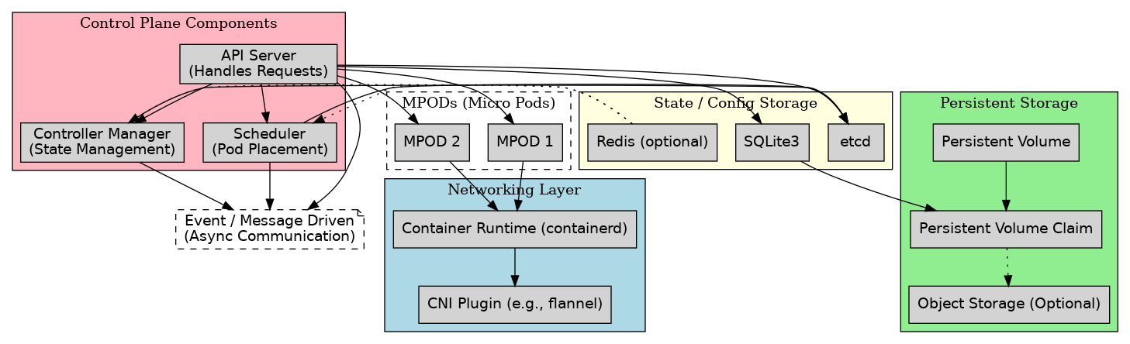

# Fig-3

# Future Enhancements (Dashboard, Monitoring, GPU Orchestration, etc.)

Planned features include a web dashboard, integrated observability stack, GPU workload scheduling, security improvements, and multi-tenant orchestration.

# Timing Diagram:

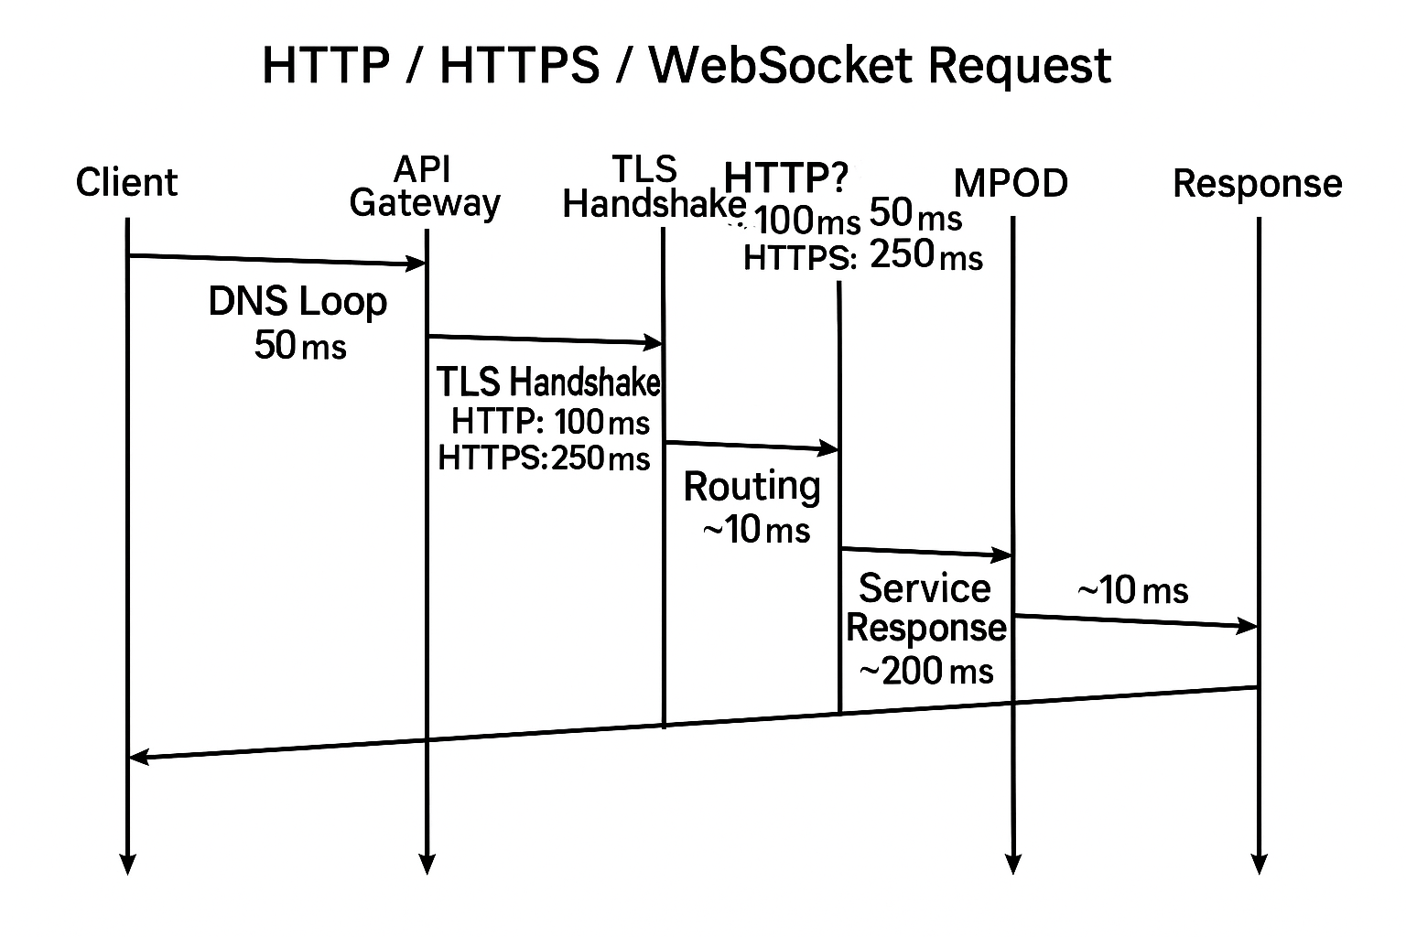

**Fig-4**

# OptiFlow (AI-OrchestrateX): Key Highlights

1. **Domain-Specific Orchestration Platform:**

* Designed to adapt and serve across **multiple business domains** like.

1. Healthcare & Medical Imaging (e.g., organ segmentation, diagnosis flows)
2. Manufacturing.
3. Retail & E-commerce
4. Space Systems
5. Molecular Structure Analysis
6. **Kubernetes-Inspired Architecture:**

* Built with similar core concepts to Kubernetes:

1. API Server
2. Controller Manager
3. Scheduler
4. Distributed DB (SQLite/Postgres initially)
5. Networking Layer

* Lightweight yet powerful—designed to run even in **WSL Ubuntu**, optimized for edge use cases.

1. **AI-Driven Orchestration**

* Embeds AI/ML for:

1. Smart scheduling
2. Resource prediction
3. Data flow automation
4. Failure detection and self-healing
5. **Custom API Gateway and Load Balancer**

* Built-in **API Gateway and L7 Load Balancer**

1. Handles **HTTP/HTTPS/WebSocket** traffic
2. Supports **routing**, **throttling**, **auth**, and **monitoring**
3. Optimized turnaround time: *API GW → LB → MPOD → Response*
4. **Modular Microservices (MPODs):**

* Runs workloads in **MPODs** (Modular Pods)
* Each MPOD can host microservices, AI models, or domain services
* Supports real-time health checks and async task execution

1. **Database-Oriented Design:**

* Uses SQLite (local) and Postgres (prod-ready) for:
* Nodes, workloads, events, Scheduling_queue, Registry, health_checks, users, GPU_metrics etc
* Easy to query, visualize, and back up

1. **Hybrid Deployment Ready:**

* **Deployable on:**

1. Local dev (WSL, laptops, finally I was planning to deploy it in Vcenter vsphere).
2. Cloud (GCP, AWS, OCI)
3. On-prem hardware (with GPU support)
4. **Highly Extensible & Plug-and-Play:**

* Easily plug in:

1. AI models
2. Monitoring tools
3. Event processors
4. External DBs or storage
5. **Optimized for Real-World SLAs:**

* **Emphasis on:**

1. Low latency
2. High throughput
3. Fault tolerance
4. Performance tracking from request to response
5. **Future-Ready Vision:**

* Targeted to evolve into a **business-grade orchestration engine**

1. For **enterprise automation**, **AI pipelines**, and **data engineering flows.**
2. With support for **multi-tenant**, **multi-cloud**, and **multi-domain** setups.

# Why OptiFlow Is Enterprise-Ready

|  |  |
| --- | --- |
| **Feature** | **Enterprise Relevance** |
| Domain-specific orchestration | Tailored solutions for healthcare, retail, space, etc. |
| AI/ML-native support | Enterprises demand AI integration for intelligent automation |
| **API Gateway + L7 Load Balancer** | Suitable for large-scale service management |
| MPOD architecture | Microservice-oriented, cloud-agnostic, scalable |
| Async health checks, scheduler | Ensures high availability and fault tolerance |
| Modular + pluggable | Integrates with existing enterprise systems |
| Cloud/on-prem/edge deployment | Fits any enterprise IT landscape |
| Future dashboard + monitoring | Aligns with enterprise observability needs |

# How to Target Enterprise Teams

1. **Focus on Use Case-Driven Value:**

* Present **industry-specific benefits**:

e.g. "In healthcare, OptiFlow automates organ segmentation and model deployment workflows end-to-end."

1. **Highlight Flexibility and Control:**

* Emphasize how OptiFlow is **not locked to a single cloud or vendor**.
* Enterprises value **ownership** and **customization**.

1. **Stress Reliability and Scale:**

* Talks about **horizontal scalability** with MPODs (supports to HS with MPODs).
* Mention **health checks**, **async control loops**, **low latency response chain**

1. **Security and Compliance:**

* OptiFlow can support
* Role-based access control (RBAC)
* Secure API Gateway endpoints
* On-prem deployments for data-sensitive environments

1. **Integration Friendly:**

* Easily integrates with:
* Enterprise APIs
* Existing AI models
* Logging/Monitoring tools
* Postgres, Redis, external storage

1. **Roadmap for Observability & Dashboards:**

* Share your vision to include:
* Web UI for managing workflows/MPODs
* Monitoring and alerting hooks
* Enterprise-grade analytics panel

# Advanced information:

* **Security Model** (RBAC, API Gateway auth, data isolation).
* **Integration Strategy** (how OptiFlow fits with existing tools).
* **SLAs & Observability Plan** (monitoring, alerting, metrics)
* **Deployment Modes** (standalone, cloud-native, hybrid, GPU-aware edge).

# LLMs in OptiFlow: Native Support

|  |  |
| --- | --- |
| **Capability** | **OptiFlow Support for LLMs** |
| LLM Deployment as MPODs | Yes — LLMs (e.g., GPT, LLaMA, Mistral) can be deployed in MPOD containers or services |
| GPU-Aware Scheduling | Yes — OptiFlow tracks GPU-capable nodes and schedules LLM inference accordingly |
| Load Balancing LLM APIs | Yes — Integrated API Gateway + Load Balancer can route user prompts to multiple LLM replicas |
| Async LLM Execution | Yes — Supports non-blocking inference jobs, WebSocket-based interaction if needed |
| Fine-tuning / Custom LLM jobs | Yes — LLM training/fine-tuning jobs can be orchestrated as batch or long-running MPODs |
| Multi-modal Model Pipelines | Yes — Chain LLMs with image/audio models (e.g., VQA, captioning) via OptiFlow workflows |
| Serving Open-source LLMs | Yes — Easily deploy and route to models like Falcon, Mistral, LLaMA, etc. |
| Prompt Routing / Versioning | Yes — OptiFlow Gateway can intelligently route prompts to the right version/model (v1, v2, etc.) |

# Example: LLM Flow in OptiFlow

***Client Request → OptiFlow API Gateway → Load Balancer → MPOD (LLM Inference Node w/ GPU) → Response***

* **Health checks** verify LLM availability.
* **Controller** ensures MPOD restart if failure.
* **Scheduler** routes large LLM prompts to nodes with enough RAM/VRAM.

# OptiFlow and LLM workflow:

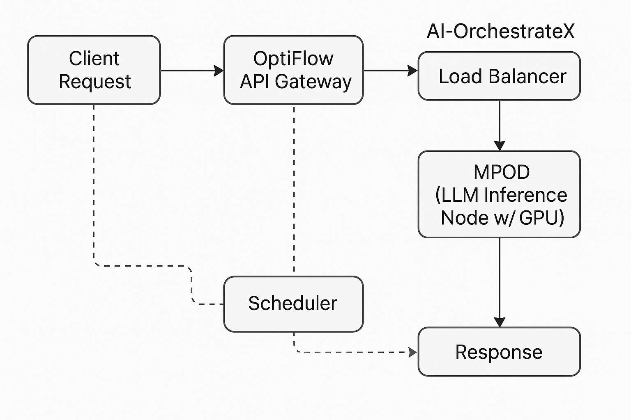

**Fig-5**

**NOTE:**

* Dotted lines represent internal orchestration and scheduling control paths handled by OptiFlow’s controller and scheduler components.
* Solid lines represent the **main execution flow of the LLM request**, from the client through the API Gateway, Load Balancer, MPOD (LLM), and back to the response

# Future Enhancements (Already in Plan)

* UI for managing **LLM pipelines and prompt history**
* Support for **LLM chaining and orchestration** (RAG, tool usage)
* Integration with **vector DBs** and **embedding services**
* Auth + rate-limiting for **LLM APIs**